# Analysis – system level

Post-elicitation stage done with all analysts after the initial interviews and document reviews. Do this first.

## Actors

First step in analysis is to brainstorm and validate these roles and systems.

* **Installer**
* **Customer**
* **Admin**
* **System**

### Unused

* Restocker
* Owner
* Credit card processor
* Wholesaler
* Purchaser for supplies

## Use case names

Second step in analysis is to brainstorm and validate scope at the goal level.

### System use cases

Only those use cases which start after the software is running and an actor directly interacts with the system.

Grouped use cases are either system or business use cases and can be groups of value/goal level use cases or groups of partial use cases like used in this example. Also common in this section are the Manage Entity type of use case which expands into the CRUD use cases. e.g. Manage Account = Create Account, Read Account (Display details of account), Update Account, Delete Account.

* Advertise product

### Business use cases

Any use case that does not completely exist as an interaction between software and the actor.

* Install machine
* Remove machine

### Use case diagram

Here would be a good place to put a Visio diagram(s) showing the relationships of all the use cases.

[Customer]-(Purchase product),

(Purchase product with cash)^(Purchase product),

(Purchase product with credit card)^(Purchase product),

(Purchase product with Apple pay)^(Purchase product),

[Installer]-(Install machine),

[Installer]-(Remove machine),

[Installer]-(Maintain machine),

[Admin]-(Run report),

[System]-( Advertise product)

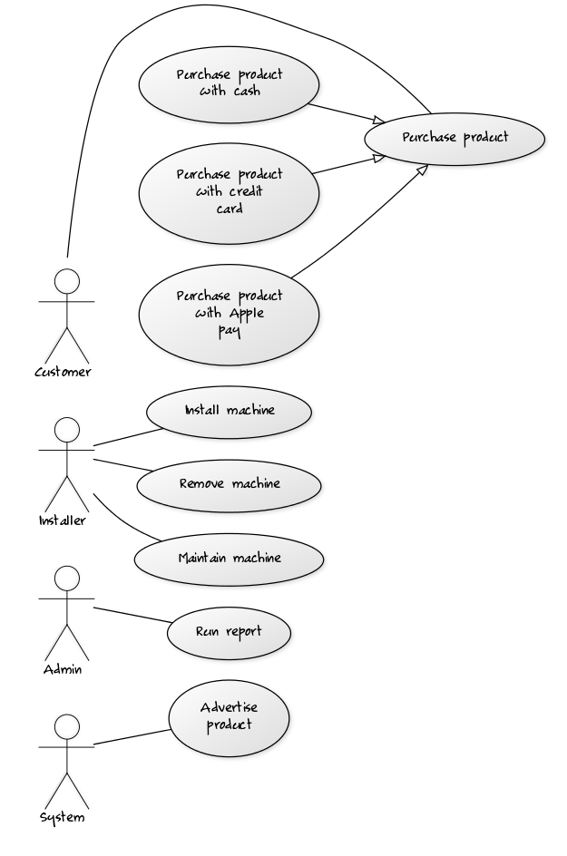

## Use case groups found

Use cases can be structured to roll up to a group name. Helpful to reduce complexity.

* Run report
  + Popular items
  + Popular times
  + Daily transaction report
  + Reconciliation
* Purchase product
  + With Apple Pay
  + With cash
  + With credit card
* Maintain machine
  + Remove cash
  + Restock inventory
  + Remove stuck product
* Replace parts
  + Replace cash system
  + Replace credit system
  + Replace delivery system
  + Replace internet service system

## Partial goal names found

Use cases can be structured to drill down to a named sequence of tasks not ending in a goal or repeatable. Helpful to identify reusable parts.

* Process transaction
* Dispense food
* Return change